**PROJECT REPORT**

BACHELOR OF VOCATIONAL ARTIFICIAL INTELLIGENCE &

DATA SCIENCE

*IN*

(A.Y.2025-2026)

By

Siddheshwari Patil(Roll No:6)

SUBJECT(WEB DEVELOPMENT-II)

Choice Based Credit Grading System with Holistic Student Development

(CBCGS-HME 2023)

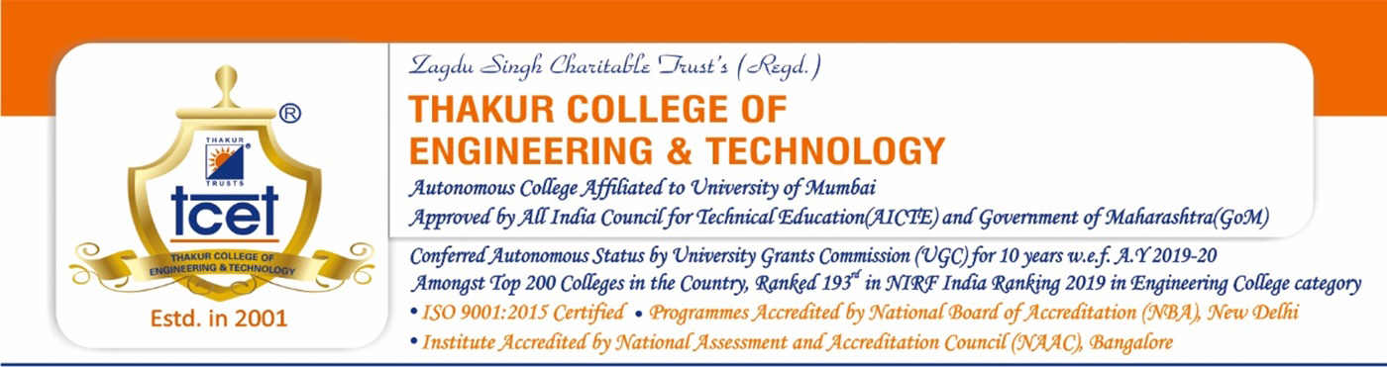Department of Bachelor of Vocational (2025-2026)

**CERTIFICATE**

This is to certify Mr./Ms. _________ student of B.VOC Department,

Thakur College of Engineering and Technology, Mumbai. They have satisfactorily completed the requirements of PROJECT as prescribed by **THAKUR COLLEGE OF ENGINEERING AND TECHNOLOGY(An Autonomous College affiliated to**

**University of Mumbai),** while working on

“_________________________________________________”.

Signature: _ _ _ _ _ _ _ _ _ _ _ _ _ _ _ _Name:

Subject Faculty In-charge

Thakur College of Engineering and Technology, Kandivali(East) Mumbai.

Date:

Place: